UCS PYTHON CODE

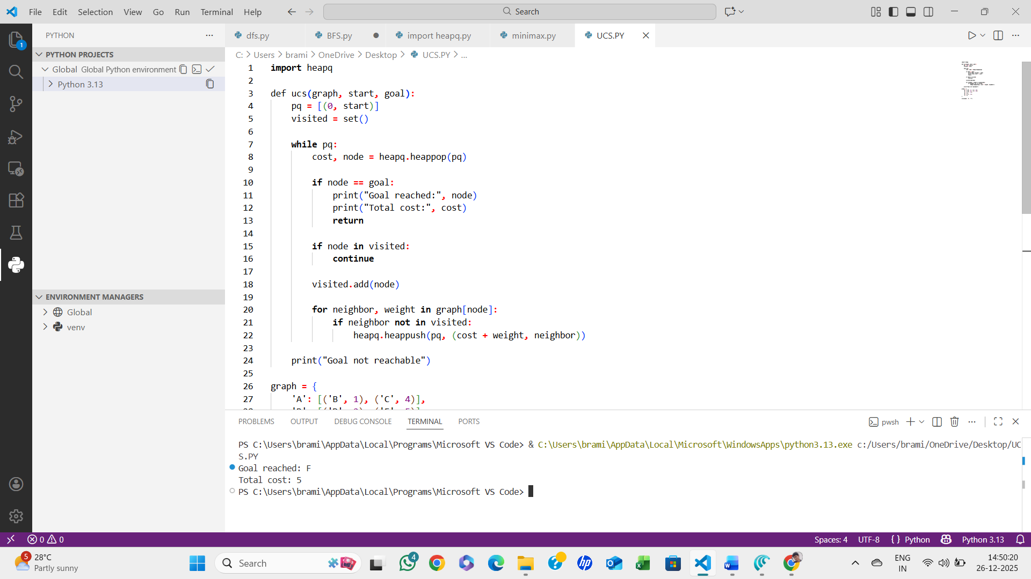

ALGORITHM:
- Start with a priority queue (min-heap) ordered by path cost
- Insert the start node with cost 0
- While the queue is not empty:
  - Remove the node with the lowest cost
  - If it is the goal, stop
  - Expand the node and add/update neighbors with cumulative cost
- Continue until goal is reached
- STOP.

